ASSIGNMENT -1

Q.1) TOTAL NUMBER OF EMPLOYEES??

select * from dept; select *from emp; select count(*) from emp;

ANSWER -

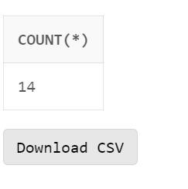

QUES 2.) Total Number of departments? ANSWER .) select count(*) from dept;

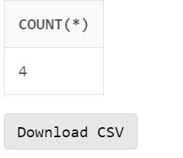

QUES 3.) All the employees?? select ename from emp;

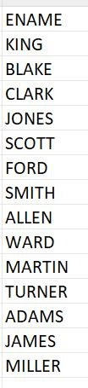

Ques 4.) All The departments ? select dname from dept;

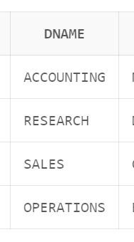

Ques 5.) Total salary paide for all employees??

Answer select sum(sal) from emp;

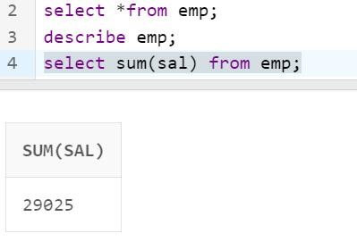

Q 6.) Total Commission paid for all employees?

select sum(comm) from emp;

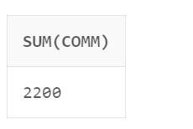

Q 7.) Which job Ttiles of the emplyees get Commission Paid?? select job as job_title,comm from emp where comm is not null;

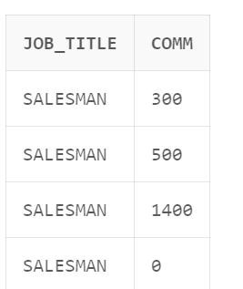

Ques.8) System Date ?? select sysdate from dual;

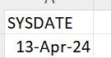

Ques.9) Average Salary Paid to all employees?

Ans .) select avg(sal) from emp;

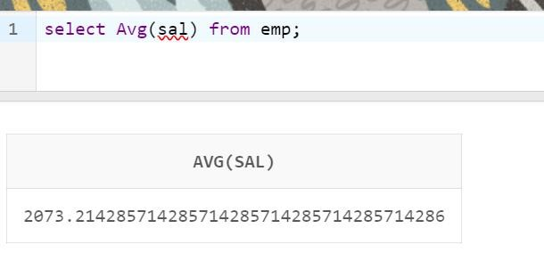

Ques.10) How Many Employees are their in each department?

select d.dname, count(*) from emp e full outer join dept d on e.deptno = d.deptno group by d.dname;

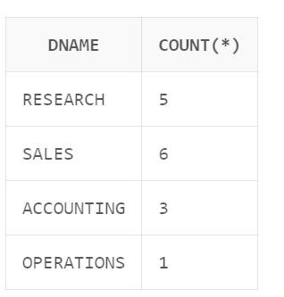

Ques.11.) ) Total Salary of the Employees in each department?

select d.dname,sum(e.sal) from emp e full outer join dept d on e.deptno = d.deptno group by d.dname;

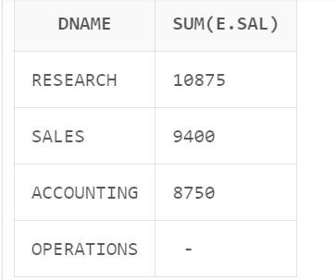

or select deptno, sum(sal) from emp group by deptno;

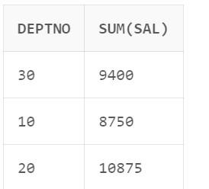

Ques.12) How Many employees are their under each job Title??

select job,count(*) from emp group by job;

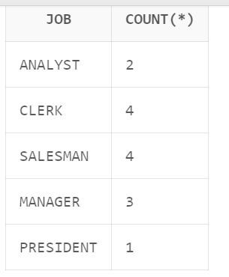

or select ename, job, count(*) from emp group by ename, job order by ename, job;

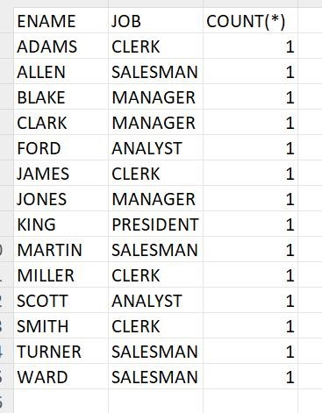

13.) Average salary paid for each job title? select job,avg(sal) from emp group by job;

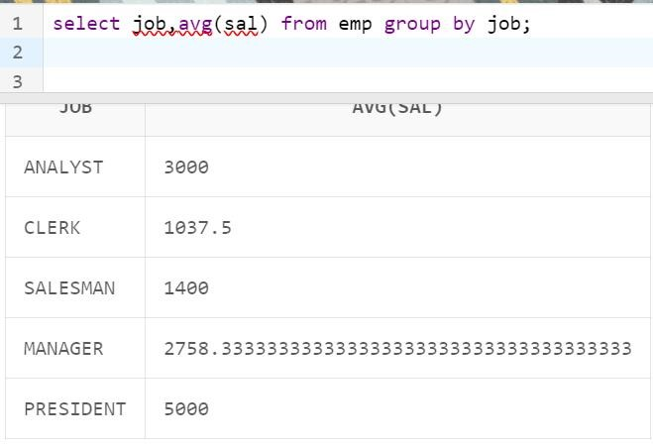

Ques 14.) Hiredate,day month for each employee? select ename, hiredate, to_char(hiredate,'YYYY'), to_char(hiredate,'MON'), to_char(hiredate,'DD') from emp;

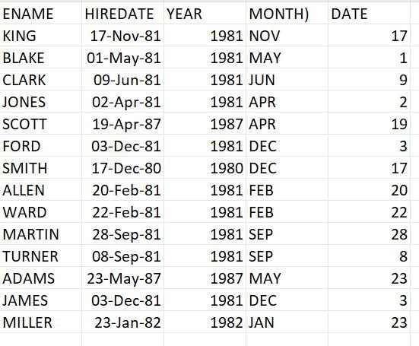

Ques 15.) SORT THE EMPLOYEES DEPARTMENT WISE?

select dname,ename from emp full outer join dept on emp.deptno=dept.deptno order by dname asc;

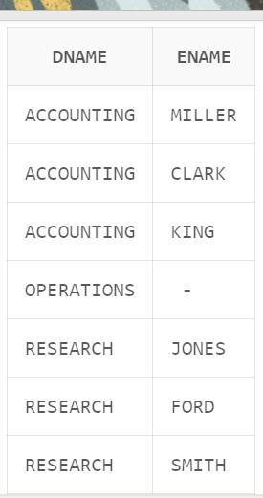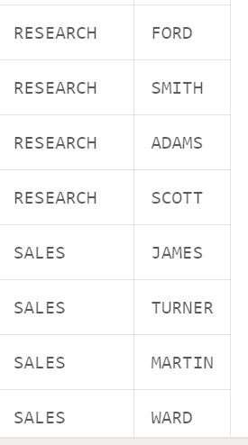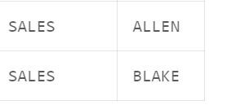

Ques 16.) Sort all the employees based on their JOB title?

SELECT ename ,job FROM emp ORDER BY ename ASC, job ASC

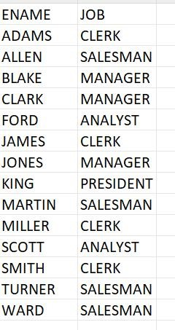

Ques 17.) Sort the employees based on the decending order of their salary?

SELECT empno , ename, sal FROM emp ORDER BY sal desc;

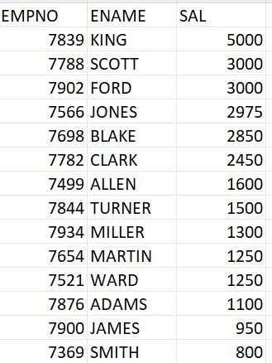

Ques 18.) Sort the employees Asscending order of their department and descending order of their salary?

select e.ename,d.dname,e.sal from emp e full outer join dept d on e.deptno=d.deptno order by d.dname,sal desc;

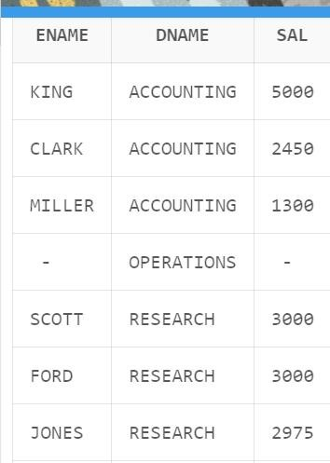

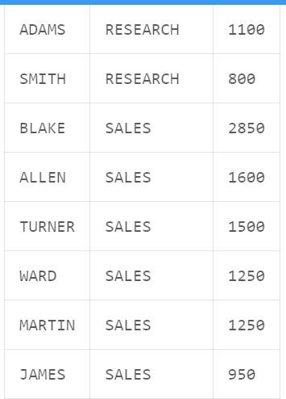

or

SELECT ename, deptno , sal FROM emp ORDER BY deptno asc , sal desc;

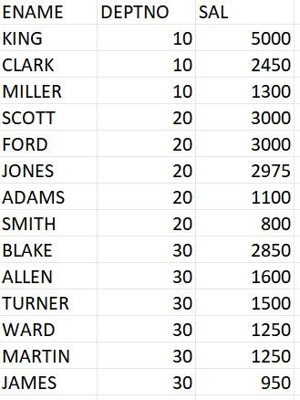

Ques 19) How Many employees have their name with 6 character?

select count(ename) from emp where length(ename)=6;

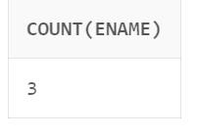

or

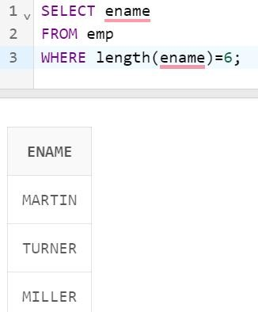

Ques 20.) Maximum and minimum salary paid?

select max(sal) from emp; select min(sal) from emp;

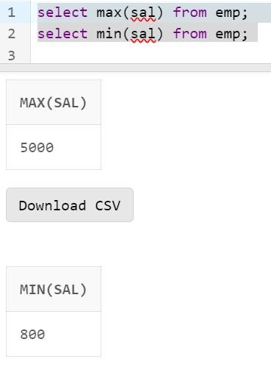

Ques 21.) Maximum , minimum , average , sum salary paid to each department ?

select dname,max(sal),min(sal),sum(sal),avg(sal) from emp e full outer join dept d on e.deptno=d.deptno group by d.dname;

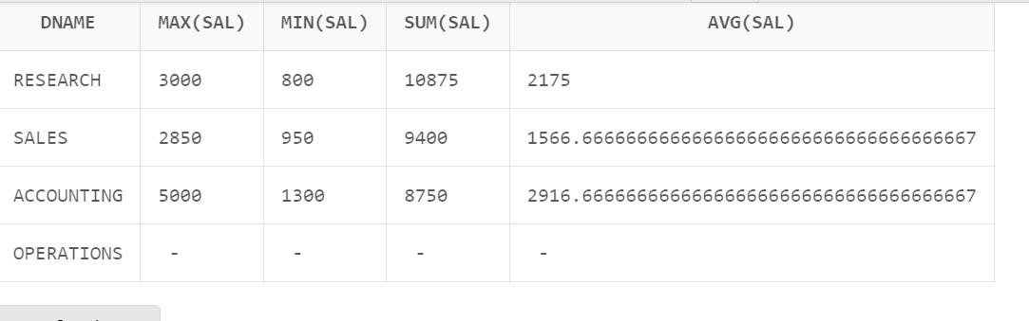

or

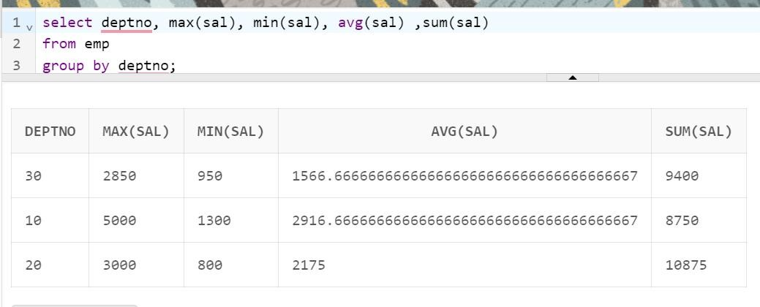

Ques 22.) SORT the employees based on their hiredates? select ename,hiredate from emp order by hiredate;

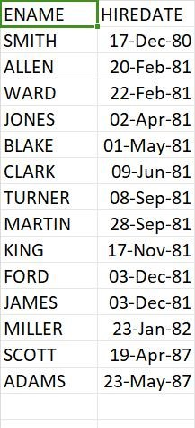

Ques 23.) Employees who joined LATEST? select ename,hiredate from emp where hiredate = (select max(hiredate) from emp);

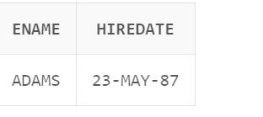

Ques 24.) Who is the latest employees in the organization based on their hiredate ? select ename,hiredate from emp where hiredate = (select min(hiredate) from emp);

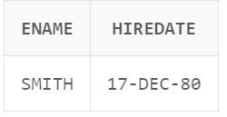

Ques 25.) Sort the employees based on hire year (descending) and department number (Ascending) ?

select e.ename,e.hiredate,d.dname from emp e

full outer join dept d on e.deptno=d.deptno order by to_char(e.hiredate,'YYYY') desc,d.dname;

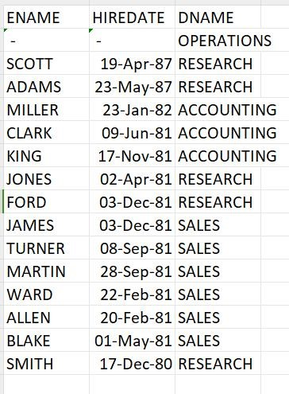

QUES.26) Emp who get salaries greater than or equal to avg sal of the emp?

ANS.) select ename,sal from emp where sal>= (select avg(sal) from emp);

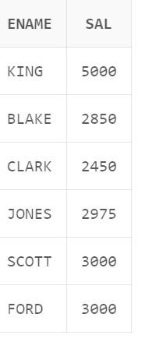

QUES .27) Employees who get sal less than or equal to avg sal of emp? ANS) Select ename,sal from emp where sal<= (select avg(sal) from emp);

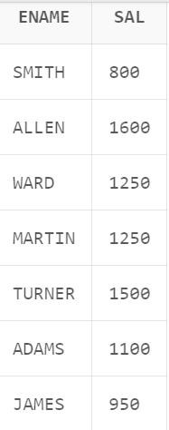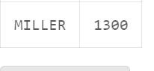

QUES.28) employees get sal b/w 2000 and 4000??

ANS)

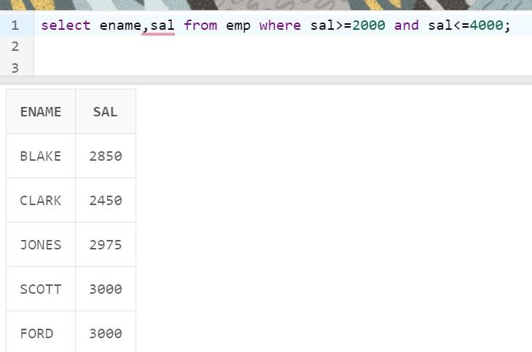

QUES.29) Which employees get highest and lowest sal?

select ename,sal from emp where sal=(select max(sal) from emp) union select ename,sal from emp where sal=(select min(sal) from emp);

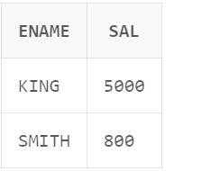

QUES.30) How many gifts need buy next month?

select count(*) from emp where to_char(hiredate, 'mm') = to_char(add_months(current_date, 1), 'mm');

